DOCUMENTATION OF The Mole

By: Mar Emerson Cardiel

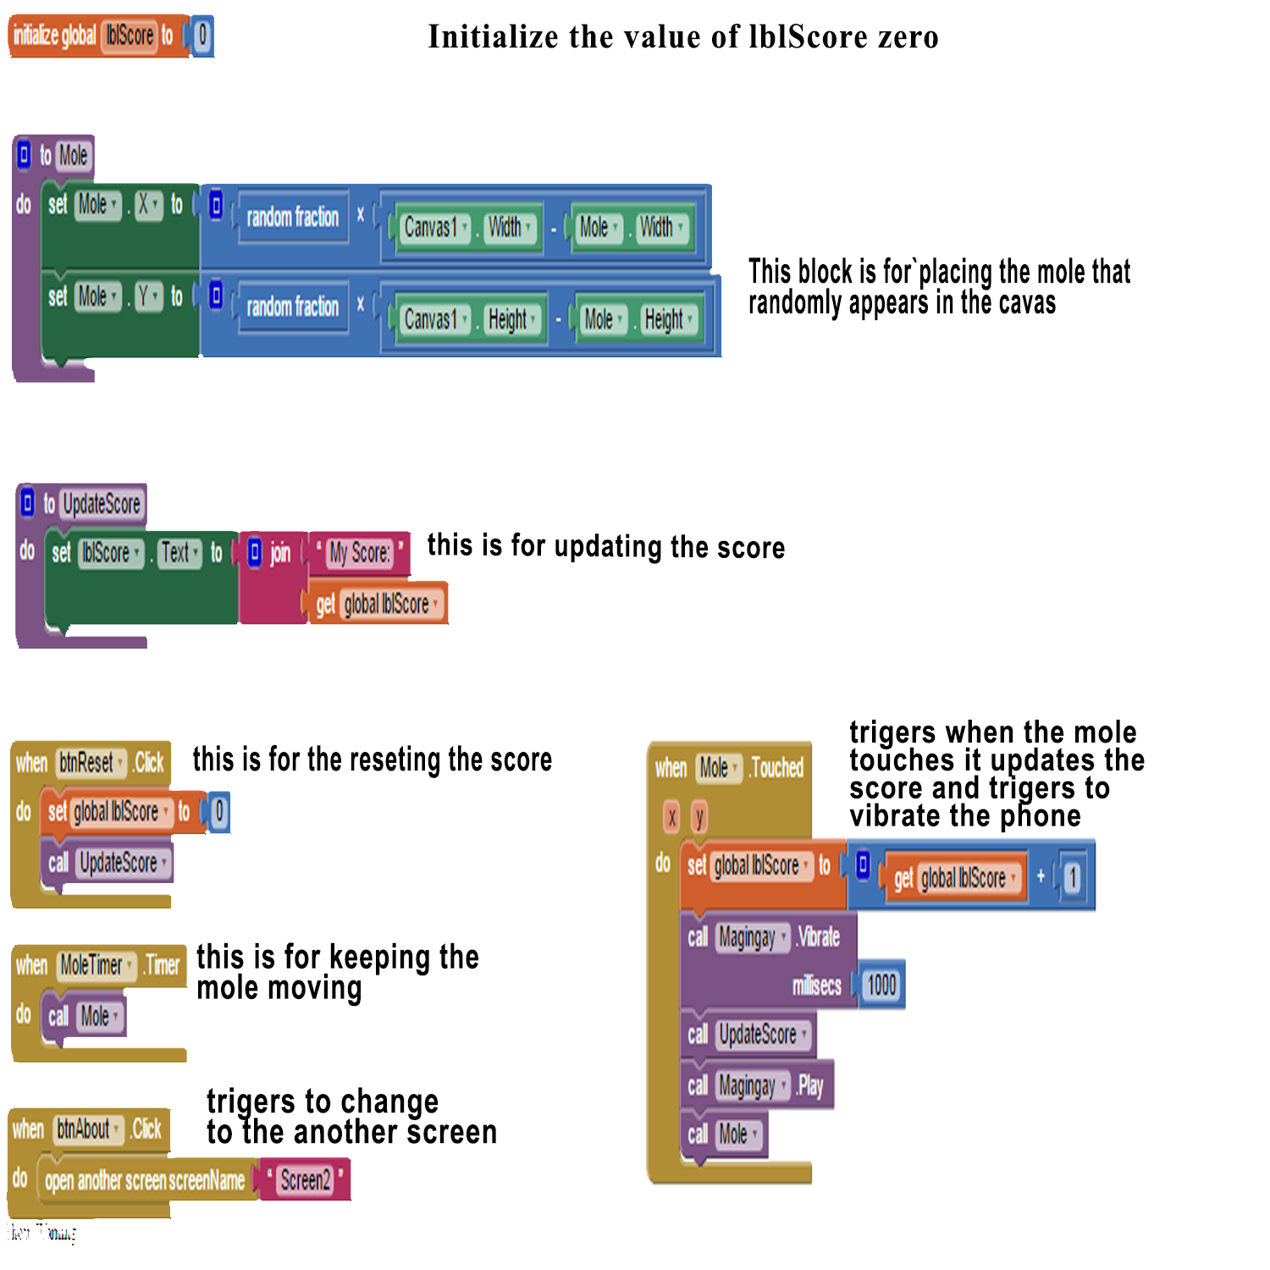Main page

About Screen

